

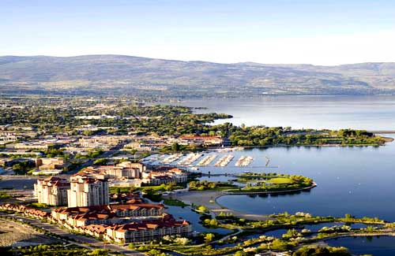

JKA-BC KARATE SUMMER CAMP KELOWNA, B.C.
July 19th -22nd 2018
Camp Description
This karate summer camp will focus on JKA technical development and further growth in your fundamentals including application. Kata’s learned at the camp will be Tekki Nidan, Tekki Sandan, Jitte, Hangetsu. Advanced kata’s being taught will include Chinte, Meikyo, Gankaku, and Wankan.

The second goal of the seminar is giving an opportunity for our members from beginner to our most advanced Black belts to take exams. Exams will be offered from 9th kyu to 1st kyu, Shodan and Nidan.

Reminder the purpose is to struggle by strenuous effort for the betterment of manners and technique and to cultivate friendship among participants.

Contact info: info@kelownakarate.ca (250)-870-3662
Chief Instructor- Sensei Don Sharp, JKA 6th Dan
1996 World Cup Champion, World Championship WKF Silver medalist 1997, 11 time National Champion, JKA A level Instructor, B level Judge, B level examiner, 3 time Canadian Martial arts Athlete of the year.
Guest Instructor-Sensei Mark Deschatelets 5th Dan JKA
Assistant Chief Instructor- Sensei Paul Atkin, JKA 4th Dan
Current JKA National team member, Bronze men's kumite JKA National Championships, mixed national team 2001, 2006 Ozawa Cup team kumite gold champion, Silver individual kumite champion, 11 time provincial champion, 5 time Provincial team member.
JKA-BC Guest Instructors-Sensei Mike Doherty 5th Dan JKA, Sensei Sal Sharp 5th Dan JKA, Sensei Harry Sidhu 4th Dan JKA, Sensei Joe Lappan 3rd Dan JKA, Sensei Brock Smith 3rd Dan JKA

REGISTRATION INFO-
Early Bird Special Registration: (Before Saturday July 7th 2018)
Juniors-$105.00 full seminar or $25.00 per class.
Adults-$130.00 full seminar or $30.00 per class.
Adults 1st kyu & up-$140.00 full seminar, $30.00 per class.

Same Day/ Late Registration (After Saturday July 7th 2018)
Juniors-$125.00 full seminar, $30.00 per class.
Adults-$155.00 full seminar, $35.00 per class.
Adults 1st kyu & up-$165.00 full seminar, $35.00 per class.

All members over the age of 4 years old can participate.
If you have registered for the full seminar the beach class is included!!
If you're not attending the full-seminar the beach class is only $20.00 extra.
Payment Information:
-Please make cash or cheque payable to Kelowna Karate and Fitness Inc.
-All Payment in for Early Bird Special by Saturday July 7th 2018.
*Any payments made after this date will pay the full regular fee amount.*
-If clubs can collect, and fill out all club registration and issue 1 cheque please. Thank you.
Mailing address-#10-1925 Kirschner Rd. Kelowna, B.C. V1Y-4N7
II. DAN/KYU GRADINGS
-Follow JKA-BC protocol for preparation for grading.
-Grading time scheduled for Saturday July 21st at 1:00pm at Kelowna Karate Dojo upstairs.

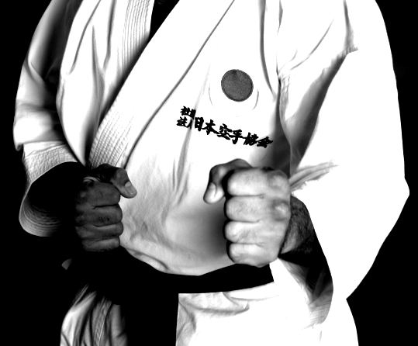
III.LOCATIONS
A.) DOJO
#10-1925 Kirschner Rd. Kelowna, B.C. V1Y-4N7
B.) ARENA-Saturday
Central Sports Club, 1155 Ellis St. Kelowna B.C.
C.) GYRO BEACH/PARK-Friday
Gyro Beach at 3400 Lakeshore Rd.
D.) BERTRAM PARK- Sunday
5680 Lakeshore Rd, Kelowna, B.C. V1W-4J4
D.) SUMMER CAMP PARTY- Saturday night
Kelowna Karate Dojo 10-1925 Kirschner Rd.
6:00-9:30pm

IV. KIDS TOTAL AMOUNT OF CLASSES (4-14 YEARS OLD)
White to Purple belt -6 classes (plus beach class.)
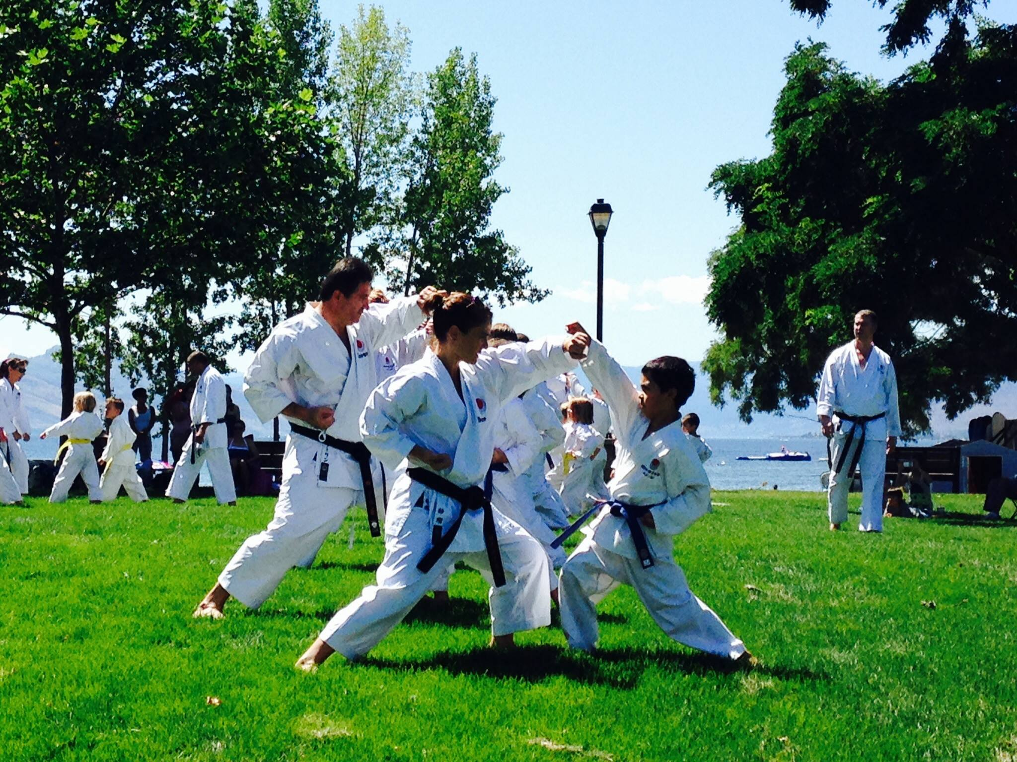
Brown belt -8 classes (plus beach class.)
Black black belt -8 classes (plus beach class.)

V. ADULT TOTAL AMOUNT OF CLASSES
White to Purple belt -6 classes (plus beach.)
Brown belt-8 classes (plus beach.)
Black belt- 8 classes (plus beach.)

2 LOCATION BEACH CLASS INFORMATION!!!!
Friday Location:
- Gyro Beach at 3400 Lakeshore Rd in the Mission 10:00am-1:00pm.
(Training area will be located far left side of the beach, next to water activity retails.) Make sure to be early for parking, and your invited to stay and socialize with your fellow Karate-ka.
Sunday Location:
- Bertram Park 5680 Lakeshore Rd, Kelowna, B.C. V1W-4J4
Meet by the beach for last training before going into the lake in your dogi (uniform.) Expect to get wet!!!!!

VI. PRE-ORDER SUMMER CAMP T-SHIRTS
$25.00 for t-shirt $25.00 tank top
Pre-order's only!!! Must have order in by July 1st 2018.

VII. ACCOMODATION

Fairfield Inn & Suites by Marriott Kelowna
1655 Powick Road,
Kelowna, BC V1X 4L1
T: 250-763-2800
www.marriott.com/YLWFI

Arrive: Thursday July 19th
Departure: Sunday July 22nd
Number of rooms reserved under Kelowna Karate:10
Room Types: Double room: 2 double beds 4 guests.
Nightly rate-$199/night

- FREE Deluxe Hot Breakfast Bar
- FREE Wireless & Wired Internet
- FREE Parking (Bus Parking also available)
- Outdoor Pool, Hot Tub & *4 Story Waterslide (Open year-round, Pool & Ground are heated!)
- 24 Hour Fitness Room
- 24 Hour Business Library (2 computers & printers for guest use)
- Use of our "Great Room" for Lunch, Dinner, or small group meetings

CAMPING GROUNDS:
Willow Creek Family Campground 3316 Lakeshore Rd, Kelowna- (250)-762-6302
Hiawatha R.V. Park 3795 Lakeshore Rd, Kelowna-(250)-861-4837
Kelowna Karate Parking Lot is also available for people with recreational vehicles that would like to use. (No Water or electrical hook-up.) Please email Sensei Paul to book a spot for free. info@kelownakarate.ca
HOMESTAY:
(Please notify Paul Sensei by July 1st if possible for limited spots www.kelownakarate.ca

JAPAN KARATE ASSOCIATION OF BRITISH COLUMBIA
SUMMER CAMP SCHEDULE
THURSDAY July 19th

CLASS. 1 | CLASS.1
5:00-6:15PM  KIDS  White to Green  Sensei Don Sharp/ Sensei Paul Atkin  Dojo 1st floor | 5:00-6:15PM  KIDS  Blue to Brown  Sensei Sal Sharp  Dojo 2nd Floor
CLASS.2 | CLASS.2
6:30-7:45PM  ADULTS  White to 2nd Kyu Brown  Sensei Sal Sharp/ Sensei Paul Atkin  Dojo 1st floor | 6:30-7:45PM  ADULTS  1st Kyu to All Black belts  Sensei Don Sharp  Dojo 2nd Floor

FRIDAY July 20th
CLASS.1
10:00-11:15AM
KIDS
All belt levels
Sensei Don Sharp/ Sensei Sal Sharp/ Sensei Paul Atkin
Gyro Beach (Far left side on the grass.)
CLASS.2
11:30-1:00PM
KIDS/ADULTS
Brown/ Black belts
Sensei Don Sharp/ Sensei Sal Sharp/ Sensei Paul Atkin
Gyro Beach (Far left side on the grass.)
Bonus Dan Candidate
3:15-4:30pm
Sensei Don Sharp- Dojo
CLASS.3 | CLASS.3
5:00-6:15PM  KIDS  White to Green  Sensei Mike Doherty/ Sensei Joe Lapaan  Dojo 1st floor | 5:00-6:15PM  KIDS  Blue to Brown  Sensei Paul Atkin  Dojo 2nd floor
CLASS.4 | CLASS.4
6:30-7:45PM  ADULTS  White to Brown  Sensei Mark Deschatelets  Dojo 1st floor | 6:30-7:45PM  ADULTS/YOUTH  Black belt/ Dan Candidates  Sensei Don Sharp  Dojo 2nd floor

SATURDAY July 21st
CLASS.1
9:00-10:15AM
KIDS & ADULT
All belt levels
Sensei Don Sharp/ Sensei Mark Deschatelets
Arena
CLASS.2
10:30-12:00PM
Arena
KIDS  White to Green  Sensei Harry Sidhu/ Sensei Joe Lappan | ADULT  White to Green  Sensei Ashraf Aomeria | ADULT/KIDS  Blue to Purple  Sensei Paul Atkin |  | ADULT/KIDS  All Brown belts  Sensei Sal Sharp/ Sensei Brock Smith | ADULT/YOUTH  Black belts only  Sensei Mike Doherty
KYU/DAN GRADINGS
1:00-2:15PM
Dojo 2nd Floor
CLASS.3
1:15-2:30PM
ADULTS
White to Purple
Sensei Mark Deschatelets
Dojo 1st Floor
CLASS.4
2:45-4:00PM  Kids under the age of 12  White to Purple  Sensei Don Sharp/ Sensei Brock Smith  Dojo 2nd floor |  |  | 2:45-4:00PM  Adult/Youth  Brown and Black belts  Sensei Paul Atkin/ Sensei Joe Lappan  Dojo 1st floor
PARTY AND GRADING RESULTS
6:00-9:00PM

SUNDAY July 22th
CLASS.1
9:45-11:OOAM  ADULTS  White to Purple  KIDS:Purple only  Sensei Brock Smith  Dojo 1st floor | 9:45-11:15AM  ADULTS  Brown/Blackbelts  Instructors Course  Sensei Don Sharp  Dojo 2nd Floor
CLASS.2
11:15-12:15PM  KIDS/ADULT  Brown/ Black belt  Sensei Mark Deschatelets/ Sensei Sal Sharp  Dojo 1st Floor & 2nd Floor | 11:15-12:15PM  (TBD)
BEACH CLASS
1:15-2:15PM
KIDS/ADULTS
ALL MEMBERS!!
White to Black
Sensei Don Sharp
(Bertram Park)

JAPAN KARATE ASSOCIATION OF BRITISH COLUMBIA
SUMMER CAMP CLUB REGISTRATION LIST
NAME | AGE | RANK | HOW MANY CLASSES | FULL SEMINAR | T-shirt $25  Tank top shirt $25  Junior or Adult Male/Female  sizes:XS,S,M,L,XL | AMOUNT
John Smith  EXAMPLE | 9 | 7th kyu  Orange belt | 6  + Beach | FULL | Junior t-shirt Small | $130.00  EXAMPLE
Amy Dow  EXAMPLE | 34 | 1st kyu  Brown belt | 8  + Beach | FULL | Adult female tank top  Medium | $155.00  EXAMPLE
Tim Smith | 36 | Shodan | 8  + Beach | FULL | Adult Male  X-Large | $165.00  EXAMPLE
 |  |  |  |  |  | Total:

